Methods of Collection interface
There are many methods declared in the Collection interface. They are as follows:
No. | Method | Description
1 | public boolean add(E e) | It is used to insert an element in this collection.
2 | public boolean addAll(Collection<? extends E> c) | It is used to insert the specified collection elements in the invoking collection.
3 | public boolean remove(Object element) | It is used to delete an element from the collection.
4 | public boolean removeAll(Collection<?> c) | It is used to delete all the elements of the specified collection from the invoking collection.
5 | default boolean removeIf(Predicate<? super E> filter) | It is used to delete all the elements of the collection that satisfy the specified predicate.
6 | public boolean retainAll(Collection<?> c) | It is used to delete all the elements of invoking collection except the specified collection.
7 | public int size() | It returns the total number of elements in the collection.
8 | public void clear() | It removes the total number of elements from the collection.
9 | public boolean contains(Object element) | It is used to search an element.
10 | public boolean containsAll(Collection<?> c) | It is used to search the specified collection in the collection.
11 | public Iterator iterator() | It returns an iterator.
12 | public Object[] toArray() | It converts collection into array.
13 | public <T> T[] toArray(T[] a) | It converts collection into array. Here, the runtime type of the returned array is that of the specified array.
14 | public boolean isEmpty() | It checks if collection is empty.
15 | default Stream<E> parallelStream() | It returns a possibly parallel Stream with the collection as its source.
16 | default Stream<E> stream() | It returns a sequential Stream with the collection as its source.
17 | default Spliterator<E> spliterator() | It generates a Spliterator over the specified elements in the collection.
18 | public boolean equals(Object element) | It matches two collections.
19 | public int hashCode() | It returns the hash code number of the collection.

Iterator interface
Iterator interface provides the facility of iterating the elements in a forward direction only.

Methods of Iterator interface
There are only three methods in the Iterator interface. They are:
No. | Method | Description
1 | public boolean hasNext() | It returns true if the iterator has more elements otherwise it returns false.
2 | public Object next() | It returns the element and moves the cursor pointer to the next element.
3 | public void remove() | It removes the last elements returned by the iterator. It is less used.

Iterable Interface
The Iterable interface is the root interface for all the collection classes. The Collection interface extends the Iterable interface and therefore all the subclasses of Collection interface also implement the Iterable interface.
It contains only one abstract method. i.e.,
- Iterator<T> iterator()
It returns the iterator over the elements of type T.

Collection Interface
The Collection interface is the interface which is implemented by all the classes in the collection framework. It declares the methods that every collection will have. In other words, we can say that the Collection interface builds the foundation on which the collection framework depends.
Some of the methods of Collection interface are Boolean add ( Object obj), Boolean addAll ( Collection c), void clear(), etc. which are implemented by all the subclasses of Collection interface.

List Interface
List interface is the child interface of Collection interface. It inhibits a list type data structure in which we can store the ordered collection of objects. It can have duplicate values.
List interface is implemented by the classes ArrayList, LinkedList, Vector, and Stack.
To instantiate the List interface, we must use :
- List <data-type> list1= new ArrayList();
- List <data-type> list2 = new LinkedList();
- List <data-type> list3 = new Vector();
- List <data-type> list4 = new Stack();
There are various methods in List interface that can be used to insert, delete, and access the elements from the list.

List in Java
➲ A list in Java is a collection for storing elements in sequential order. Sequential order means the first element, followed by the second element, followed by the third element, and so on.
A good realtime example of a list is a line of train bogies on a track: To get to the fourth bogie from the first bogie, we have to go through the second and third bogies in that order.
➲ Java list is a sub-interface of the collection interface that is available in java.util package. Sub interface means an interface that extends another interface is called sub interface. Here, the list interface extends the collection interface.
The general declaration of list interface in java is as follows:
public interface List<E> extends Collection<E>
➲ It is an ordered collection where elements are maintained by index positions because it uses an index-based structure. In the list interface, the order is retained in which we add elements. We will also get the same sequence while retrieving elements.
➲ It is used to store a collection of elements where duplicate elements are allowed.
➲ List interface in java has four concrete subclasses. They are ArrayList, LinkedList, Vector, and Stack. These four subclasses implements the list interface.
ArrayList and LinkedList are widely used in Java programs to create a list. The Vector class is deprecated since JDK 5.

Features of List Interface in Java

There are the following features of list in java. They are as follows:
1. The list allows storing duplicate elements in Java. JVM differentiates duplicate elements by using ‘index’. Index refers to the position of a certain object in an array. It always starts at zero.
For example, assume that there is a list with size 10. Suppose the first element is ‘a’ at zero index position and the second element is also ‘a’ which is at 9th position. Thus, there are two ‘a’ elements in the list at positions 0 and 9 respectively.
So, JVM will differentiate between both elements in the list based on their numeral position of the index. Therefore, the index is very useful and plays an important role to differentiate objects.
2. In the list, we can add an element at any position.
3. It maintains insertion order. i.e. List can preserve the insertion order by using the index.
4. It allows for storing many null elements.
5. Java list uses a resizable array for its implementation. Resizable means we can increase or decrease the size of the array.
6. Except for LinkedList, ArrayList, and Vector is an indexed-based structure.
7. It provides a special Iterator called a ListIterator that allows accessing the elements in the forward direction using hasNext() and next() methods.
In the reverse direction, it accesses elements using hasPrevious() and previous() methods. We can add, remove elements of the collection, and can also replace the existing elements with the new element using ListIterator.

How to create a List in Java?
To create a list in java, we can use one of its two concrete subclasses: ArrayList, and LinkedList. We will use ArrayList to create a list and test methods provided by list interface in the program section.
List p = new ArrayList();
List q = new LinkedList();
List r = new Vector();
List s = new Stack();

How to create Generic List Object in Java
After the introduction of Generic in Java 1.5, we can restrict the type of object that can be stored in the list. The general syntax for creating a list of objects with a generic type parameter is as follows:
1. List<data type> list = new ArrayList<data type>(); // General sysntax.

For example:
List<String> list = new ArrayList<String>(); // Creating a list of objects of String type using ArrayList.
List<Integer> list = new LinkedList<Integer>(); Creating a list of objects of Integer type using LinkedList.
List<String> list1 = new LinkedList<String>();
d. List<obj> list = new ArrayList<obj>(); // obj is the type of object.

For example:
List<Book> list=new ArrayList<Book>(); // Book is the type of object.

2. Starting from Java 1.7, we can use a diamond operator.
a. List<String> str = new ArrayList<>();
b. List<Integer> list = new LinkedList<>();

Java List Initialization
After creating a list, we need to initialize the list by adding elements to it. There are three methods to initialize the list. They are as follows:
- Using Arrays.asList
- Using Normal way
- Using Anonymous Inner class
Go to this tutorial for more detail: ArrayList in Java

Java List Methods
Java List interface provides 10 specific and useful methods to the out of 15 methods specified by the collection interface that it extends. These methods can be used to initialize a list in java. They are as follows:
1. boolean add(Object o): It starts to add the specified element from zero location. If the element is already present at zero location, it will add the next element in one position.
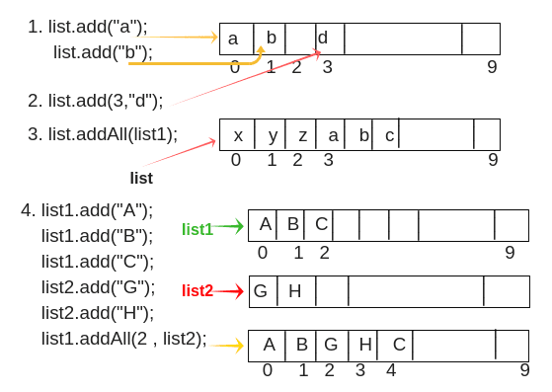
For example, consider 1 in the above figure.
list.add("a"); // Here, list is object reference variable.
list.add("b");
The return type of add() method is boolean and input type is an object.
2. void add(int index, Object o): This method adds/inserts the specified element at a particular position in the list. For example, suppose we want to add element “d” at 3rd position, we will call add(int index, Object o ) method like this:
list.add(3,"d"); // It will add element "d" at 3rd position as shown in figure.
3. boolean addAll(Collection c): Here, Collection c represents a group of elements. This method is used to add/insert a group of elements at the end of the last element.
For example, suppose we want to add three elements x, y, and z at positions 0, 1, and 2 respectively in a list.
list.add("x");
list.add("y");
list.add("z");
Now we will create a list of another group of elements like this:
list1.add("a");
list1.add("b");
list1.add("c");
list.addAll(list1);
// It will add group of elements at the end of the last element in the list. The last element is z. So, after z, it will add list1 as shown in above figure.
4. boolean addAll(int index, Collection c): This method is used to add/insert a group of elements at a particular position in the list and shift the subsequent elements to the right by increasing their indices.
For example, suppose we want to add three elements at positions 1, 2, and 3 respectively in a list using list1 reference variable.
list1.add("A");
list1.add("B");
list1.add("C");
Now we will create a list of another group of elements using list2 reference variable.
list2.add("G");
list2.add("H");
Assume that we want to add this group of elements at position 2 of the list1. So, we will call addAll(int index, Collection c) method like this:
list1.addAll(2, list2); // You will see that element C is shifted to right at position 4 as shown in the figure.
5. object remove(int index): It is used to remove an element at a specified position in the list. For example, consider the above figure.
list1.remove(2); // It will remove the element at 2nd position and element D which is at 3rd position, will be shifted to the left at the 2nd position. The output will be A, B, D.
6. object get(int index): This method is used to return element/object stored at a specified position in the list. The return type of get() method is Object and input type is int[index of List].
For example:
list1.get(2); // Output will be 'C'.
7. int indexOf(Object o): It is used to return the index of a particular element of the first occurrence in the list. If the element is not present in the list then it will return -1. It takes as an argument as an element and returns as an integer value of that element as it is index value.
For example, suppose an element ‘A’ is present at position 0 and the same element is also present at position 9 in the list.
list.indexOf("A"); // It will return integer value of an element "A" of first occurrence. i.e from zero position, not from position 9. So the output is 0.
8. int lastIndexOf(Object o): It returns the index of the last occurrence of a specified element in the list. If the list does not contain that particular element, it will return -1.
For example:
list.lastIndexOf("A"); // Output will be 9.
9. object set(int index, Object o): This method replaces the existing element at the specified position in the list with new specified element.
For example:
list1.set(2, "Z");
10. ListIterator listIterator(): It returns listIterator of the elements in the list in a proper sequence.
11. ListIterator listIterator(int): This method returns a listIterator of the elements in the list in proper sequence, starting at the specified position in the list.

List Example Programs
Let’s create an example program where we will add both integer and string elements together. So, we will not use generic in this program.
Program source code 1:
package listPrograms;
import java.util.ArrayList;
import java.util.List;
public class AddEx
{
public static void main(String[] args)
{
// Create a List.
List al = new ArrayList(); // Here, there is no use of generic. So, no type safety. We can add both integer and string elements.

// Adding elements using add() method with reference variable al.
al.add(10);
al.add(20);
al.add(30);
al.add(40);
al.add("Shubh");

// Adding element to 4th position.
al.add(4, 35);
// Adding element to 5th position.
al.add(5, 45);
System.out.println("Elements after adding: " +al);
}
}
Output:
Elements after adding: [10, 20, 30, 40, 35, 45, Shubh]
Let’s create a program where we will create a list 1 and another list 2. We will add elements of list 2 into list 1 at position 2. Look at the source code to understand better.
Program source code 2:
package listPrograms;
import java.util.ArrayList;
import java.util.List;
public class AddAllEx
{
public static void main(String[] args)
{
// Create a list1 of only String type. This means that Compiler will give errors if we try to put any elements other than String type.
List<String> al = new ArrayList<String>();
al.add("Apple");
al.add("Mango");
al.add("Orange");
al.add("Grapes");
System.out.println("List1 contain: " +al);

// Create another List2 of String type.
List<String> al2 = new ArrayList<String>();
al2.add("11");
al2.add("12");
al2.add("13");
System.out.println("List2 contain :-"+al2);

// Adding List2 in List1 at 2nd position(i.e index=2) using addAll() method.
al.addAll(2, al2);
System.out.println("List1 after adding List2 at 2nd position :-"+al);
}
}
Output:
List1 contain: [Apple, Mango, Orange, Grapes]
List2 contain: [11, 12, 13]
List1 after adding List2 at 2nd position: [Apple, Mango, 11, 12, 13, Orange, Grapes]
Program source code 3:
package listPrograms;
import java.util.ArrayList;
import java.util.List;
public class IndexOfEx
{
public static void main(String[] args)
{
List al = new ArrayList();
al.add("AA");
al.add("BB");
al.add("CC");
al.add("DD");
al.add("EE");
al.add("FF");

// To find the Index of any particular element, use obj.indexOf(object o) method.
System.out.println("Index of CC: "+al.indexOf("CC"));
System.out.println("Index of FF: "+al.indexOf("FF"));
}
}
Output:
Index of CC: 2
Index of FF: 5
Program source code 4:
package listPrograms;
import java.util.ArrayList;
import java.util.List;
public class GetMethodEx
{
public static void main(String[] args)
{
List al = new ArrayList();
// Adding Element using reference variable al.
al.add("pen");
al.add("pencil");
al.add("ink");
al.add("notebook");
al.add("book");
al.add("paper");
// Now call get(int index) method to get elements from specified index and print them.
System.out.println("First Element: " +al.get(0));
System.out.println("Fourth Element: " +al.get(3));
}
}
Output:
First Element: pen
Fourth Element: notebook
package com.me.bvimit;
// Java program to demonstrate
// list() method
// for Integer value

import java.util.*;
public class list2Demo {

public static void main(String[] argv) throws Exception
{
try {

// creating object of List<String>
List<Integer> arrlist = new ArrayList<Integer>();

// creating object of Vector<String>
Vector<Integer> v = new Vector<Integer>();

// Adding element to Vector v
v.add(10);
v.add(20);
v.add(30);
v.add(40);
v.add(50);

// printing the list
System.out.println("Current list : " + arrlist);

// creating Enumeration
Enumeration<Integer> e = v.elements();

// getting arrlist of specified Enumeration
// using list() method
arrlist = Collections.list(e);

// printing the arrlist
System.out.println("Returned list: "
+ arrlist);
}

catch (IllegalArgumentException e) {
System.out.println("Exception thrown : " + e);
}
}
}
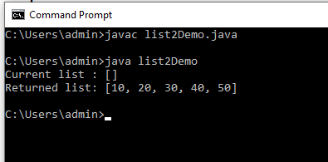

// Java program to demonstrate
// list() method
// for Integer value

import java.util.*;
public class list2Demo {

public static void main(String[] argv) throws Exception
{
try {

// creating object of List<String>
List<Integer> arrlist = new ArrayList<Integer>();

// creating object of Vector<String>
Vector<Integer> v = new Vector<Integer>();

// Adding element to Vector v
v.add(10);
v.add(20);
v.add(30);
v.add(40);
v.add(50);

// printing the list
System.out.println("Current list : " + arrlist);

// creating Enumeration
Enumeration<Integer> e = v.elements();

// getting arrlist of specified Enumeration
// using list() method
arrlist = Collections.list(e);
// printing the arrlist
System.out.println("Returned list: "
+ arrlist);
}

catch (IllegalArgumentException e) {
System.out.println("Exception thrown : " + e);
}
}
}

Java List vs ArrayList
List is an interface whereas ArrayList is an implementation class that implements the List interface.

When to use List?
There are the following points for using list in java application that should be to keep in mind. They are:
1. List can be used when we want to allow or store duplicate elements.
2. It can be used when we want to store null elements.
3. When we want to preserve my insertion order, we should go for list.

Hierarchy Diagram of ArrayList Class in Java
The hierarchy diagram of ArrayList class is shown in the below figure.
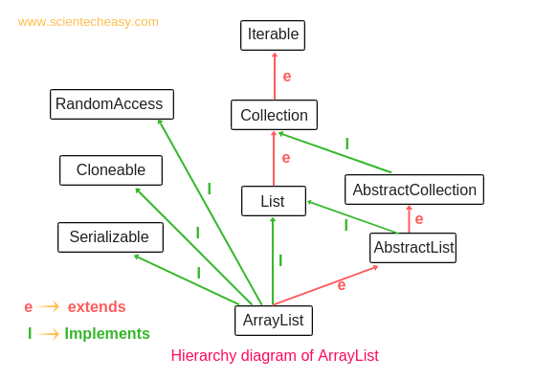

String s1 = "Hello";
String s2 = "Hello";
String s = new String("Hello");
char arr[ ] = {'j','a','v','a'};
String s = new String(arr);

Types of Iterators in Java
There are four types of iterators or cursors available in Java. They are as follows:
- Enumeration
- Iterator
- ListIterator
- Spilterator
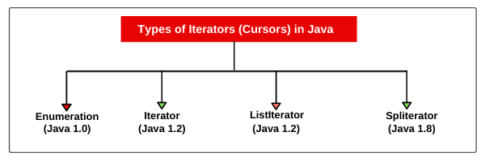
Each Java iterator has some advantages and limitations.

Difference between Enumeration and Iterator
Both are useful to retrieve elements from a collection. But the main difference between Enumeration and iterator is with respect to functionality.
By using an enumeration, we can perform only read access but using an iterator, we can perform both read and remove operation.

Advantage of Iterator in Java
Java Iterator has the following advantages. They are as follows:
- An iterator can be used with any collection classes.
- We can perform both read and remove operations.
- It acts as a universal cursor for collection API.

Limitation of Iterator in Java
Iterator has the following limitations or drawbacks. They are as:
- By using Enumeration and Iterator, we can move only towards forwarding direction. We cannot move in the backward direction. Hence, these are called single-direction cursors.
- We can perform either read operation or remove operation.
- We cannot perform the replacement of new objects.
- For example, suppose there are five mangoes in a box. Out of five, two mangoes are not good but we cannot replace those damaged mangos with new mangos.

java.util.Enumeration interface Examples

Creating Enumeration Object
Vector ve = new Vector();
Enumeration e = v.elements();

public interface Enumeration<E>
Where E is the type of elements stored in a Collection.
The sub-interfaces of Enumeration interface is NamingEnumeration and implementing class is

// Java program to test Enumeration
import java.util.Vector;
import java.util.Enumeration;

public class EnumerationClass {

public static void main(String args[])
{
Enumeration months;
Vector<String> monthNames = new Vector<>();

monthNames.add("January");
monthNames.add("February");
monthNames.add("March");
monthNames.add("April");
monthNames.add("May");
monthNames.add("June");
monthNames.add("July");
monthNames.add("August");
monthNames.add("September");
monthNames.add("October");
monthNames.add("November");
monthNames.add("December");
months = monthNames.elements();

while (months.hasMoreElements()) {
System.out.println(months.nextElement());
}
}
}

public class HashTableEnumerationDemo {
public static void main(String[] args) {
Hashtable<Integer, String> h = new Hashtable<>();
h.put(1,"A");
h.put(2,"B");
h.put(3,"C");
h.put(4,"D");
h.put(5,"E");
h.put(6,"F");
h.put(7,"G");
h.put(8,"H");
h.put(22,"I");
h.put(0,"K");
h.put(23,"J");
h.put(25,"L");
System.out.println(h);
// Obtaining keys as enumeration from Hashtable
Enumeration<Integer> e = h.keys();
while (e.hasMoreElements()) {
Integer key = (Integer) e.nextElement();
System.out.println("[key"+key+", value="+h.get(key)+"]");
}
}
}
{22=I, 8=H, 7=G, 6=F, 5=E, 4=D, 3=C, 25=L, 2=B, 1=A, 23=J, 0=K}
[key22, value=I]
[key8, value=H]
[key7, value=G]
[key6, value=F]
[key5, value=E]
[key4, value=D]
[key3, value=C]
[key25, value=L]
[key2, value=B]
[key1, value=A]
[key23, value=J]
[key0, value=K]

import java.util.Enumeration;
import java.util.Vector;
public class EnumerationTest
{
public static void main(String[] args)
{
// Create an object of vector class using generic.
Vector<Integer> v = new Vector<Integer>();
for(int i=0; i<=10; i++)
{
v.addElement(i);
}
System.out.println(v);
Enumeration e = v.elements();
while(e.hasMoreElements())
{
Integer i = (Integer)e.nextElement(); // Direct type casting in one step.
System.out.println(i);
}
Enumeration en = v.elements();
while(en.hasMoreElements())
{
Integer it = (Integer)en.nextElement();
if(it % 2 == 0)
{
System.out.println(it);
}
}
}
}
Output:
[0, 1, 2, 3, 4, 5, 6, 7, 8, 9, 10]
0 1 2 3 4 5 6 7 8 9 10 0 2 4 6 8 10

Limitation of Enumeration
There are many limitations of using enumeration interface in java. They are as follows:
1. Enumeration concept is applicable for only legacy class. Hence, it is not a universal cursor.
2. We can get only read operation by using the enumeration. We cannot perform the remove operation.
3. We can iterate using enumeration only in the forward direction.
4. Java is not recommended to use enumeration in new projects.
To overcome these limitations, We should go for the next level Iterator concept in Java.

Iiterable Interface in Java
The Collection interface extends Iterable interface that is present at the top of the collection hierarchy. The iterable interface is present in java.lang.Iterable package. It provides a uniform way to retrieve the elements one by one from a collection object.
It provides just one method named iterator() which returns an instance of Iterator and provides access one by one to the elements in the collection object.
The general syntax of iterator() method is as follows:
iterator() : Iterator // Return type is Iterator.

How to create Iterator object in Java?
Iterator object can be created by calling iterator() method which is present in the iterable interface. The general syntax for creating Iterator object is as follows:
a) Iterator itr = c.iterator(); // c is any collection object.
b) Iterator<Type> itr = c.iterator(); // Generic type.

For example:
Iterator<String> itr = c.iterator();
Iterator<Integer> itr = c.iterator();
The basic working mechanism for using Java Iterator is shown in the flow diagram.
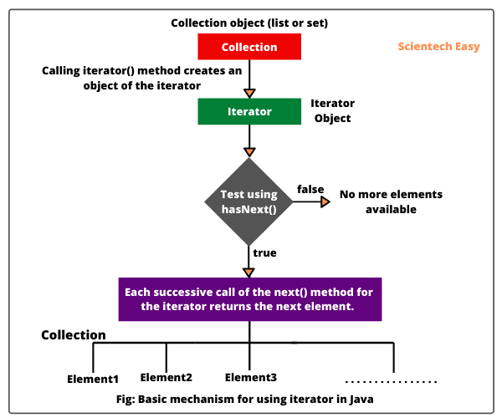
import java.util.ArrayList;
import java.util.Iterator;
public class IteratorTest
{
public static void main(String[] args)
{
ArrayList<String> al = new ArrayList<String>();
// Adding elements in the array list.
al.add("A");
al.add("B");
al.add("C");
al.add("D");
al.add("E");
al.add("F");
Iterator<String> itr = al.iterator();
while (itr.hasNext())
{
String str = itr.next();
System.out.print(str + " ");
}
}
}
Output:
A B C D E F
When we create an iterator for the collection elements, the iterator looks like the following.
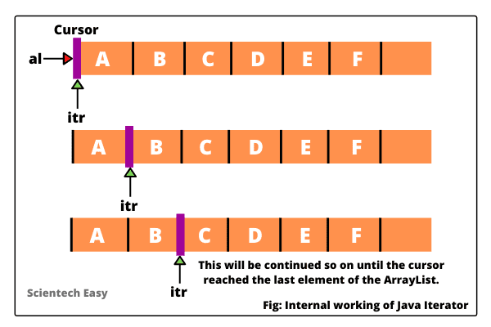

Iterator Methods in Java
The Iterator interface provides three methods in Java. They are as follow:
1. public boolean hasNext(): This method will return true if the iteration has more elements to traverse (iterate) in the forward direction. It will give false if all the elements have been iterated.
2. public Object next(): The next() method return next element in the collection. It will throw NoSuchElementException when the iteration is complete.
3. public void remove(): The remove() method removes the last or the most recent element returned by the iterator. It must be called after calling the next() method otherwise it will throw IllegalStateException.

We can iterate set by using any one of the following ways. They are as follows:
- Using Iterator
- Using Enhanced for loop
- Using forEach()
import java.util.HashSet;
import java.util.Iterator;
import java.util.Set;
public class IterateSetEx
{
public static void main(String[] args)
{
// Create a generic set object of type String.
Set<String> s = new HashSet<String>(); // s.size() is 0.
int size = s.size();
System.out.println("Size before adding elements: " +size);

// Adding elements to set.
s.add("Orange"); // s.size() is 1.
s.add("Red"); // s.size() is 2.
s.add("Blue"); // s.size() is 3.
s.add("Yellow"); // s.size() is 4.
s.add("Green"); // s.size() is 5.
System.out.println("Elements in set");
System.out.println(s);

Iterator<String> itr = s.iterator();
System.out.println("Iteration using Iterator method");
while(itr.hasNext())
{
Object str = itr.next();
System.out.println(str);
}
}
}
Output:
Size before adding elements: 0
Elements in set
[Red, Blue, Yellow, Orange, Green]
Iteration using Iterator method
Red Blue Yellow Orange Green

import java.util.HashSet;
import java.util.Set;
public class IterateSetEx2
{
public static void main(String[] args)
{
// Create Set object of type Integer.
Set<Integer> s = new HashSet<Integer>();
// Adding even numbers betwen 10 to 30 as elements.
for(int i = 10; i < = 30; i++)
{
if(i % 2 == 0)
{
s.add(i);
}
}
System.out.println("Even numbers between 10 to 30");
System.out.println(s);
System.out.println("Iteration Using Enchanced For Loop");
for(Integer it:s)
{
System.out.println(it);
}
}
}
Output:
Even numbers between 10 to 30
[16, 18, 20, 22, 24, 10, 26, 12, 28, 14, 30]
Iteration Using Enhanced For Loop
16 18 20 22 24 10 26 12 28 14 30

Third way to iterate set elements using for forEach() method.
package iterateSet;
import java.util.HashSet;
import java.util.Set;
public class IterateSetEx3
{
public static void main(String[] args)
{
Set<Character> s = new HashSet<Character>();
s.add('A');
s.add('B');
s.add('C');
s.add('D');
s.add('E');
System.out.println(s);
System.out.println("Iterating using forEach loop in Java 1.8");
s.forEach(System.out::println);
}
}
Output:
[A, B, C, D, E]
Iterating using forEach loop in Java 1.8
A B C D E

Set in Java | Set Methods, Example
A set in Java is an unordered collection of unique elements or objects. In other words, a set is a collection of elements that are not stored in a particular order. Elements are simply added to the set without any control over where they go. For example, in many applications, we do not need to care about the order of elements in a collection. Consider the below figure where a set of books by topics is not arranged. A collection of elements is not stored in a particular order into a set. Such a collection of elements without order is called set in Java.
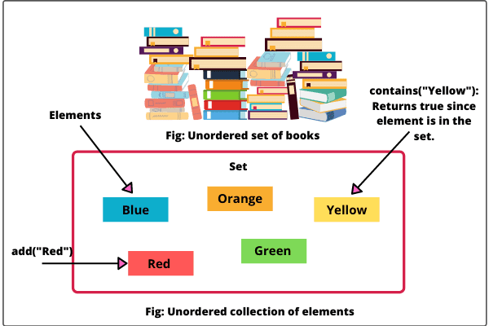
We can add elements in a set and iterate over all elements in a set. It will grow dynamically when elements are stored in it. We can also check whether a particular element is present in the set.
A set will not allow duplicate elements. That means an element can exist only once in the set. If we try to add the same element that is already present in the set, then it is not stored in the set. That’s why each element in a set is unique.
Set in Java can be used to remove duplicate elements from the collection.
Set holds a single reference to an object. It does not provide two references to the same object, two references to null, or references to two objects a and b such that a.equals(b).

Set Interface in Java
Set is an interface that was introduced in Java 1.2 version. It is a generic interface that is declared as:
interface Set<E>
Here, E defines the type of elements that the set will hold.
Java Set interface does not provide any additional methods of its own. It uses methods defined by the collection interface but places additional restrictions on those methods.
For example, when set uses add() or addAll() methods defined by the collection interface, it does not add an element to the set if the set already contains that element.
Java Set interface does not provide any get() method like List to retrieve elements. Therefore, the only way to take out elements from the set is to do using Iterator() method. But this method does not return elements from the set in any particular order.
Using the Iterator, we can traverse only in the forward direction from the first to last element. We cannot traverse over elements in the backward direction using iterator method.
Set in Java
The set interface present in the java.util package and extends the Collection interface is an unordered collection of objects in which duplicate values cannot be stored. It is an interface which implements the mathematical set. This interface contains the methods inherited from the Collection interface and adds a feature which restricts the insertion of the duplicate elements. There are two interfaces which extend the set implementation namely SortedSet and NavigableSet.

In the above image, the navigable set extends the sorted set interface. Since a set doesn’t retain the insertion order, the navigable set interface provides the implementation to navigate through the Set. The class which implements the navigable set is a TreeSet which is an implementation of a self-balancing tree.
Therefore, this interface provides us with a way to navigate through this tree.
Declaration: The Set interface is declared as:
public interface Set extends Collection
Creating Set Objects
Since Set is an interface, objects cannot be created of the type set. We always need a class which extends this list in order to create an object. And also, after the introduction of Generics in Java 1.5, it is possible to restrict the type of object that can be stored in the Set. This type-safe set can be defined as:
// Obj is the type of the object to be stored in Set
Set<Obj> set = new HashSet<Obj> ();

Operations on the Set Interface
The set interface allows the users to perform the basic mathematical operation on the set. Lets take two arrays to understand these basic operations. Let set1 = [1, 3, 2, 4, 8, 9, 0] and set2 = [1, 3, 7, 5, 4, 0, 7, 5]. Then the possible operations on the sets are:
1. Intersection: This operation returns all the common elements from the given two sets. For the above two sets, the intersection would be:
Intersection = [0, 1, 3, 4]
2. Union: This operation adds all the elements in one set with the other. For the above two sets, the union would be:
Union = [0, 1, 2, 3, 4, 5, 7, 8, 9]
3. Difference: This operation removes all the values present in one set from the other set. For the above two sets, the difference would be:
Difference = [2, 8, 9]
HashSet is one of the widely used classes which implements the Set interface.

Classes which implement the Set interface in Java Collections
1. HashSet: Hashset class which is implemented in the collection framework is an inherent implementation of the hash table datastructure. The objects that we insert into the hashset does not guarantee to be inserted in the same order. The objects are inserted based on their hashcode. This class also allows the insertion of NULL elements. Let’s see how to create a set object using this class.

2. LinkedHashSet: LinkedHashSet class which is implemented in the collections framework is an ordered version of HashSet that maintains a doubly-linked List across all elements. When the iteration order is needed to be maintained this class is used. When iterating through a HashSet the order is unpredictable, while a LinkedHashSet lets us iterate through the elements in the order in which they were inserted.

3. TreeSet: TreeSet class which is implemented in the collections framework an implementation of the SortedSet Interface and SortedSet extends Set Interface. It behaves like simple set with the exception that it stores elements in sorted format. TreeSet uses tree data structure for storage. Objects are stored in sorted, ascending order. But we can iterate in descending order using method TreeSet.descendingIterator().

Methods Present in the Set Interface
The following methods are present in the set interface:
Method | Description
add(element) | This method is used to add a specific element to the set. The function adds the element only if the specified element is not already present in the set else the function returns False if the element is already present in the Set.
addAll(collection) | This method is used to append all of the elements from the mentioned collection to the existing set. The elements are added randomly without following any specific order.
clear() | This method is used to remove all the elements from the set but not delete the set. The reference for the set still exists.
contains(element) | This method is used to check whether a specific element is present in the Set or not.
containsAll(collection) | This method is used to check whether the set contains all the elements present in the given collection or not. This method returns true if the set contains all the elements and returns false if any of the elements are missing.
hashCode() | This method is used to get the hashCode value for this instance of the Set. It returns an integer value which is the hashCode value for this instance of the Set.
isEmpty() | This method is used to check whether the set is empty or not.
iterator() | This method is used to return the iterator of the set. The elements from the set are returned in a random order.
remove(element) | This method is used to remove the given element from the set. This method returns True if the specified element is present in the Set otherwise it returns False.
removeAll(collection) | This method is used to remove all the elements from the collection which are present in the set. This method returns true if this set changed as a result of the call.
retainAll(collection) | This method is used to retain all the elements from the set which are mentioned in the given collection. This method returns true if this set changed as a result of the call.
size() | This method is used to get the size of the set. This returns an integer value which signifies the number of elements.
toArray() | This method is used to form an array of the same elements as that of the Set.

Hierarchy of Set Interface in Java
Java Set interface extends java.util.collection interface. The java.util.SortedSet interface extends the Set interface to provide the sorted set of elements.
Three classes such as HashSet, LinkedHashSet, and TreeSet implement set interface.
ConcurrentSkipListSet and EnumSet classes also implements set interface. The hierarchy diagram of the Set interface in Java is shown in below figure.
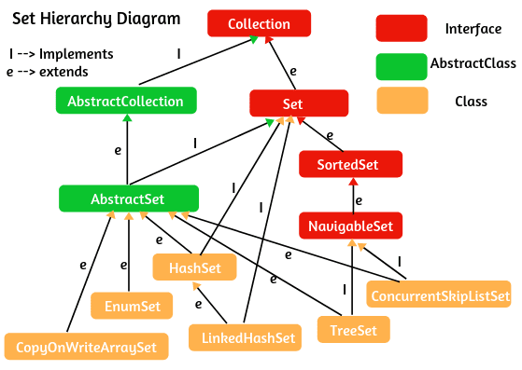

Features of Java Set
1. Set is an unordered collection of elements. That means the order is not maintained while storing elements. While retrieving we may not get the same order as that we put elements.
2. It is used to store a collection of elements without duplicate. That means it contains only unique elements.
3. Java Set uses map based structure for its implementation.
4. It can be iterated by using Iterator but cannot be iterated by using ListIterator.
5. Most of the set implementations allow adding only one null element. Tree set does not allow to add null element.
6. Set is not an indexed-based structure like a list in Java. Therefore, we cannot access elements by their index position.
8. It does not provide any get method like a list.

Java Set Implementation
Java collections framework provides three general-purpose Set implementations: HashSet, TreeSet, and LinkedHashSet.
HashSet is a concrete class that implements set interface. It uses a hash table mechanism to store its elements. It is the best-performing implementation.
TreeSet is a concrete class that implements SortedSet interface (a subinterface of set). It uses a binary search tree mechanism to store its elements. It orders its elements based on their values. It is considerably slower than HashSet.
LinkedHashSet is a concrete class that extends HashSet class. It stores its elements using hash table mechanism with a linked list implementation.
It orders its elements based on the order in which they were inserted into the set. That is, elements in the HashSet are not ordered but elements in the LinkedHashSet can be retrieved in the order in which they were inserted into the set.
This is the brief idea of set implementation classes. We will learn more detail about HashSet, TreeSet, and LinkedHashSet classes in further tutorials.

Set Methods in Java
A set interface has the following various useful methods such as add, remove, clear, size, etc to enhance the usage of a set interface in the collections framework. They are listed in the table:
Method | Description
boolean add(Object o) | It is used to add the specified element in this set.
boolean addAll(Collection c) | This method adds all the elements in the given collection.
int size() | It is used to get the number of elements in the set.
boolean isEmpty() | This method checks that the set is empty or not.
void clear() | It is used to remove all the elements from the set.
boolean contains(Object o) | This method returns true if this set contains the given element.
boolean containsAll(Collection c) | This method returns true if this set contains all the elements of the given collection.
boolean remove(Object o) | It is used to remove the specified element from this set.
boolean removeAll(Collection c) | It removes all the elements in the given collection from the set.
Iterator iterate() | It returns an Iterator over the elements in this set.
boolean equals(Object o) | It is used to compare the given element for equility in this set.
int hashCode() | It is used to get the hashCode value for this set.

Ways to create a Generic Set object in Java
We can create a generic Set object by using one of its three concrete classes: HashSet, LinkedHashSet, and TreeSet. The syntax to create set objects is as follows:
Syntax:
Set<T> set = new HashSet<T>(); where T is type of generic.
Set<T> set = new LinkedHashSet<T>();
Set<T> set = new TreeSet<T>();
For example:
Set<Integer> set = new HashSet<Integer>(); // Creates an empty set of Integer objects.
Set<String> set2 = new LinkedHashSet<String>(); // Creates an empty set of String objects.

Set Example Programs based on basic Operations
1. Adding Elements to Set: The add() method returns true if set does not contain the specified element. If set already contains the specified element then it will return false. Let’s take an example program based on it.
Program source code 1:
package setProgram;
import java.util.HashSet;
import java.util.LinkedHashSet;
import java.util.Set;
public class SetExample1
{
public static void main(String[] args)
{
// Create a generic set object of type String.
Set<String> s = new HashSet<String>();
int size = s.size();
System.out.println("Size before adding elements: " +size);

// Adding elements to set.
s.add("Orange"); // s.size()is 1.
s.add("Red"); // s.size() is 2.
s.add("Blue"); // s.size() is 3.
s.add("Yellow"); // s.size() is 4.
s.add("Green"); // Now s.size() is 5.

// Add duplicate elements in the set. These elements will be ignored by set due to not taking duplicate elements.
s.add("Red"); // s.size() is still 5 because we cannot add duplicate element.
s.add("Blue"); // s.size() is still 5 because we cannot add duplicate element.
System.out.println("Unordered Set Elements");
System.out.println(s);

// Check 'Black' element is present in the above set or not.
if(s.equals("Black"))
{
System.out.println("Black element is not present in set.");
}
else
{
s.add("Black");
System.out.println("Black is added successfully.");
System.out.println("Set Elements after adding black element");
System.out.println(s);
}
// Create another set object to add collection of elements to the above set.
Set<String> s2 = new LinkedHashSet<String>();
s2.add("White");
s2.add("Brown");
s2.add("Red"); // Duplicate element.

// Call addAll() method to add all the elements of the given collection.
s.addAll(s2);
System.out.println("Set Elements after adding elements from given collection");
System.out.println(s);
}
}
Output:
Size before adding elements: 0
Unordered Set Elements
[Red, Blue, Yellow, Orange, Green]
Black is added successfully.
Set Elements after adding black element
[Red, Blue, Yellow, Black, Orange, Green]
Set Elements after adding elements from given collection
[Red, Brown, White, Blue, Yellow, Black, Orange, Green]
In the above example program, you can observe in the output, set does not maintain the order of elements while storing. It gives an unordered collection of elements in HashSet.
To impose an order on them, we need to use the LinkedHashSet class, which we will learn in the next section.
When we add duplicate elements in the set, it rejected duplicate elements because the set does not allow duplicate elements (keep in mind these points).
2. Removing an Element from Set: Let’s take a program where we will remove an element from set. We will also check the set is empty or not before adding elements in the list.
Program source code 2:
package setProgram;
import java.util.HashSet;
import java.util.Set;
public class SetExample2
{
public static void main(String[] args)
{
// Create a generic set object of type String.
Set<String> s = new HashSet<String>();

// Check set is empty or not.
boolean check = s.isEmpty(); // Return type of this method is an boolean.
System.out.println("Is Set empty: " +check);

// Adding elements to set.
s.add("Orange");
s.add("Red");
s.add("Blue");
s.add("Yellow");
s.add("Green");
if(s.isEmpty())
{
System.out.println("Set is empty.");
}
else
{
System.out.println("Set is not empty.");
System.out.println("Elements in the Set");
System.out.println(s);
}
// Remove an element from set.
s.remove("Blue");
System.out.println("Set elements after removing");
System.out.println(s);

// Get the total number of set elements.
int size = s.size();
System.out.println("Total number of elements: " +size);
}
}
Output:
Is Set empty: true
Set is not empty.
Elements in the Set
[Red, Blue, Yellow, Orange, Green]
Set elements after removing
[Red, Yellow, Orange, Green]
Total number of elements: 4
3. Searching an Element in Set: Let’s make a program where we will search an element in set. The contains() method checks whether an element is present in the set. If it is present in the set, the method returns true, otherwise false.
Program source code 3:
package setProgram;
import java.util.HashSet;
import java.util.Set;
public class SetExample3
{
public static void main(String[] args)
{
Set<Character> s = new HashSet<Character>();
s.add('D');
s.add('F');
s.add('H');
s.add('P');
s.add('K');
s.add(null);
s.add(null); // Duplicate null element. Therefore, set allow only one null element.
System.out.println("Unordered Set Elements");
System.out.println(s);

// Call contains() method to search an element.
boolean search = s.contains('A'); // Returns false because A is not present in the set.
System.out.println("Is Element A present in set: " +search);
if(s.contains('K'))
{
System.out.println("K is present in set.");
}
else {
System.out.println("K is not present in set.");
}
int hashcode = s.hashCode();
System.out.println("HashCode value: " +hashcode);
}
}
Output:
Unordered Set Elements
[P, null, D, F, H, K]
Is Element A present in set: false
K is present in set.
HashCode value: 365

When to use Set?
1. If you want to represent a group of individual elements as a single entity where duplicates are not allowed and insertion order is not preserved then we should go for the Set.
2. If your requirement is to get unique elements, set is the best choice for this.
3. If you want to remove duplicate elements without maintaining the insertion order from the non-set collection, you should go for set.
Let’s take a simple example program where we will remove duplicate elements from the ArrayList. Look at the source code.
Program source code 4:
package setProgram;
import java.util.ArrayList;
import java.util.HashSet;
import java.util.List;
import java.util.Set;
public class SetExample4
{
public static void main(String[] args)
{
// Create a generic list object of type Integer.
List<Integer> list = new ArrayList<Integer>();
int size = list.size();
System.out.println("Size before adding elements: " +size);
list.add(5);
list.add(10);
list.add(5);
list.add(15);
list.add(20);
list.add(10);
list.add(20);
list.add(30);
System.out.println("Original order of List Elements");
System.out.println(list);

Set<Integer> s = new HashSet<Integer>(list);
System.out.println("Unodered List Elements after removing duplicates.");
System.out.println(s);
}
}
Output:
Size before adding elements: 0
Original order of List Elements
[5, 10, 5, 15, 20, 10, 20, 30]
Unodered List Elements after removing duplicates
[20, 5, 10, 30, 15]
Q. Assume that set1 is a set that contains string elements such as Banana, Orange, and Apple. set2 is another set that contains string elements such as Banana, Orange, and Mango.
Answer the following questions:
a) What are the elements of set1 and set2 after executing set1.addAll(set2)?
b) What are the elements of set1 and set2 after executing set1.add(set2)?
c) What are the elements of set1 and set2 after executing set1.removeAll(set2)?
d) What are the elements of set1 and set2 after executing set1.remove(set2)?
e) What are elements of set1 and set2 after executing set1.retainAll(set2)?
f) What is the size of set1 after executing set1.clear()?
g) What is the size of set2 after executing set2.add(“Mango”)?
Ans a: set1: [Apple, Mango, Orange, Banana], set2: [Mango, Orange, Banana]
Ans b: Compilation error: The method add(String) in the type Set<String> is not applicable for the arguments (Set<String>)
Ans c: set1: [Apple], set2: [Mango, Orange, Banana]
Ans d: set1: [Apple, Orange, Banana], set2: [Mango, Orange, Banana]
Ans e: set1: [Orange, Banana], set2: [Mango, Orange, Banana]
Ans f: After executing set1.clear(), size of set1 is 0.
Ans g: After executing set2.add(“Mango”), the size of set2 is 3 because duplicate elements cannot be added to the set.

Map in Java
A map in Java is a container object that stores elements in the form of key and value pairs.
A key is a unique element (object) that serves as an “index” in the map.
The element that is associated with a key is called value. A map stores the values associated with keys. In a map, both keys and values must be objects and cannot be primitive types.
A map cannot have duplicate keys. Each key maps to only one value. This type of mapping is called one-to-one mapping in java.
All keys must be unique, but values may be duplicate (i.e. the same value can be stored to several different keys).
A key and its associated value are called an entry that is stored in a map as shown in the below figure. After the entry (key/value pairs) is stored in a map, we can retrieve (get) its value by using its key.
The figure shows a map in which each entry consists of Id number as a key and a name as the value.
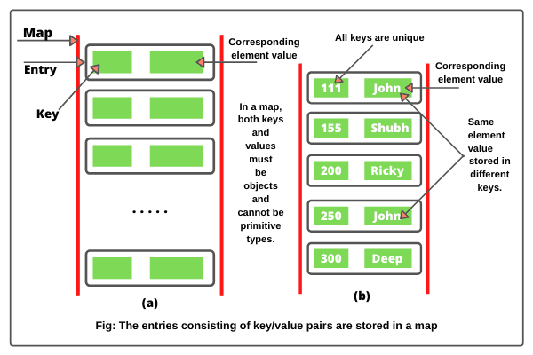
Key point: The main difference between maps and sets is that maps contain keys and values, whereas sets contain only keys.

Map Interface in Java
Map interface in Java is defined in java.util.Map package. It is a part of the Java collections framework but it does not extend the collection interface. The Map interface is not a subtype of the Collection interface. Therefore it behaves a bit differently from the rest of the collection types. A map contains unique keys.

Java map interface is defined like this:
public interface Map<K, V> // Map is a generic.
In this syntax, K defines the type of keys and V defines the type of values.
For example, a mapping of Integer keys and String values can be represented with a Map<Integer,String>. The Map interface provides the methods for fast retrieval, deletion, and updating of the pair through the key.

Map Hierarchy Diagram
The hierarchy diagram of Java Map interface is shown in the below figure.
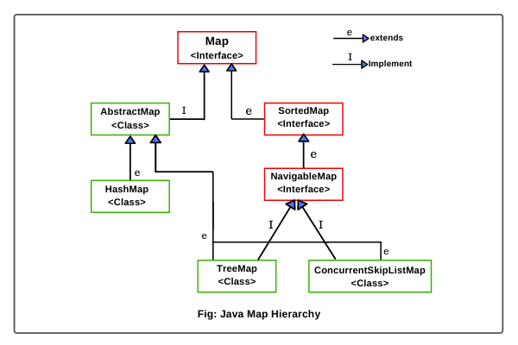

Hierarchy of HashMap class in Java
HashMap class in Java extends AbstractMap class and implements the Map interface. The hierarchy diagram of HashMap can be seen in the below figure.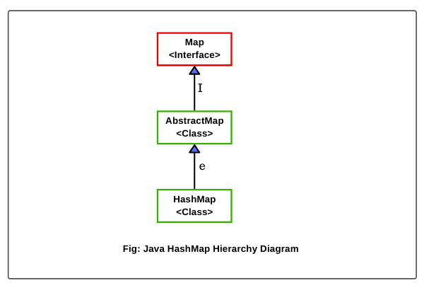

Hierarchy of LinkedHashMap in Java
LinkedHashMap implementation in Java is a subclass of HashMap class. That is, LinkedHashMap class extends the HashMap class and implements Map interface.
The hierarchy diagram of LinkedHashMap is shown in the below figure.
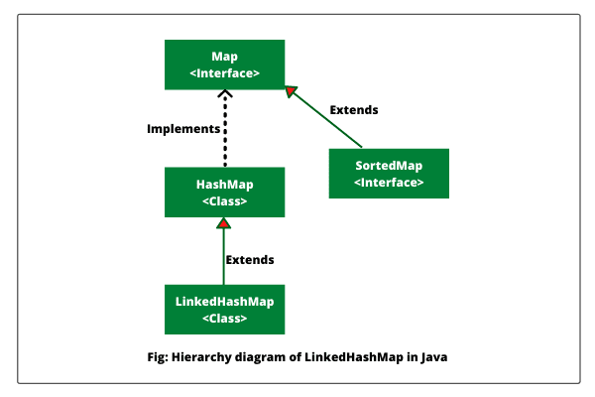

Hierarchy of TreeMap in Java
TreeMap class is the subclass of AbstractMap and implements Map, SortedMap (a subinterface of Map interface), and NavigableMap interfaces.
TreeMap also implements Cloneable and Serializable interfaces. The hierarchy diagram of TreeMap in Java is shown in the below figure.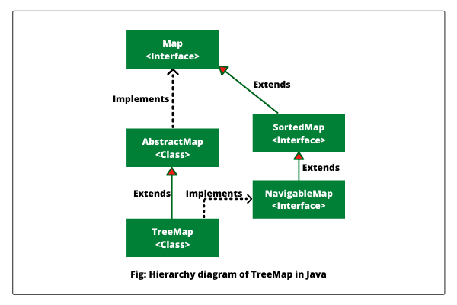

Hierarchy of WeakHashMap class in Java
WeakHashMap class extends AbstractMap class that implements Map interface. The hierarchy diagram of WeakHashMap class is shown in the below figure.
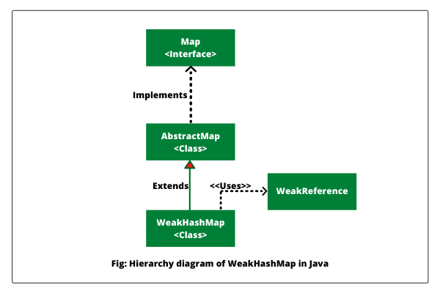
Let’s understand a brief introduction about interfaces and implementation classes shown in the hierarchy diagram of Java map.
1. SortedMap Interface: A SortedMap is a subinterface of Map interface that extends Map interface. The entries in the map are maintained in ascending order based on the keys.
SortedMap is generic and is declared like this:
interface SortedMap<K, V>
The methods defined by SortedMap interface are comparator(), entrySet(), firstKey(), headMap(K toKey), keySet(). lastKey(), etc.
2. NavigableMap Interface: NavigableMap interface is a recent addition to the Collections Framework that was added by Java 1.6 version. It extends SortedMap interface.
TreeMap and ConcurrentSkipListMap classes implement the NavigableMap interface. As the name suggest, NavigableMap provides many useful methods that make Map navigation easy.
We can retrieve entries based on the closest match to a given key. NavigableMap is a generic interface that can be declared like this:
interface NavigableMap<K, V>
The methods defined by NavigableMap interface are ceilingEntry(K key), ceilingKey(K key), descendingKeySet(), descendingMap(), firstEntry(), lastEntry(), etc.

- Adding Elements: In order to add an element to the map, we can use the put() method. However, the insertion order is not retained in the hashmap. Internally, for every element, a separate hash is generated and the elements are indexed based on this hash to make it more efficient.
- Changing Elements: After adding the elements if we wish to change the element, it can be done by again adding the element with the put() method. Since the elements in the map are indexed using the keys, the value of the key can be changed by simply inserting the updated value for the key for which we wish to change.
- Removing Element: In order to remove an element from the Map, we can use the remove() method. This method takes the key value and removes the mapping for a key from this map if it is present in the map.
- Iterating through the Map: There are multiple ways to iterate through the Map. The most famous way is to use a for-each loop and get the keys. The value of the key is found by using the getValue() method.
Characteristics of a Map Interface
- A Map cannot contain duplicate keys and each key can map to at most one value. Some implementations allow null key and null value like the HashMap and LinkedHashMap, but some do not like the TreeMap.
- The order of a map depends on the specific implementations. For example, TreeMap and LinkedHashMap have predictable order, while HashMap does not.
- There are two interfaces for implementing Map in java. They are, Map and SortedMap, and three classes: HashMap, TreeMap and LinkedHashMap.
Why and When to use Maps?
Maps are perfect to use for key-value association mapping such as dictionaries. The maps are used to perform lookups by keys or when someone wants to retrieve and update elements by keys. Some examples are:
- A map of error codes and their descriptions.
- A map of zip codes and cities.
- A map of managers and employees. Each manager (key) is associated with a list of employees (value) he manages.
- A map of classes and students. Each class (key) is associated with a list of students (value).

Classes which implement the Map interface
1. HashMap: HashMap is a part of Java’s collection since Java 1.2. It provides the basic implementation of the Map interface of Java. It stores the data in (Key, Value) pairs. To access a value one must know its key. This class uses a technique called Hashing. Hashing is a technique of converting a large String to small String that represents the same String. A shorter value helps in indexing and faster searches.
2. LinkedHashMap: LinkedHashMap is just like HashMap with an additional feature of maintaining an order of elements inserted into it. HashMap provided the advantage of quick insertion, search and deletion but it never maintained the track and order of insertion which the LinkedHashMap provides where the elements can be accessed in their insertion order.
3. TreeMap: The TreeMap in Java is used to implement Map interface and NavigableMap along with the Abstract Class. The map is sorted according to the natural ordering of its keys, or by a Comparator provided at map creation time, depending on which constructor is used. This proves to be an efficient way of sorting and storing the key-value pairs. The storing order maintained by the treemap must be consistent with equals just like any other sorted map, irrespective of the explicit comparators.

Map Implementation Classes
The collection class library has several classes that provide implementations of map interface in Java. They are as follows:
1. AbstractMap: It is an abstract class that implements map interface. It is the parent class of all concrete map implementation classes such as HashMap, TreeMap, and LinkedHashMap. It implements all methods in Map interface except entrySet() method.
2. EnumMap: The EnumMap class extends AbstractMap and implements Map interface. It is especially for use with keys of Enum type.
3. HashMap: It is a concrete class that extends AbstractMap. It uses a hash table to store elements. It is mainly used for locating a value, inserting, and deleting an entry.
4. TreeMap: It is a concrete class that extends AbstractMap and implements NavigableMap interface. It used a tree for storing elements. It is used for traversing keys in sorted order. The keys can be sorted using the Comparable interface or Comparator interface.
5. LinkedHashMap: It is a concrete class that provides implementation of Java map interface. It extends HashMap class with a linked-list implementation that supports the insertion order of entries in the map.
The entries in a HashMap are not ordered, but entries in a LinkedHashMap can be retrieved in the order in which they were inserted into the map.
6. WeakHashMap: The WeakHashMap class extends AbstractMap interface to use a hash table with keys of weak type. Weak keys allow an element in a map to be garbage collected when its key is no longer used anywhere in the program.
7. IdentityHashMap: This class extends AbstractMap and uses reference equality for comparing entries. This class is not used for general purposes.

Java Map.Entry Interface
The Map.Entry interface enables us to work on an entry in the map. An entry of a map is an object of type Map.Entry interface, where Entry is an inner interface of Map interface.
Map.Entry interface is defined in java.util.Map.Entry package. Each Map.Entry object contains one key/value pair. Map.Entry is a generic interface and is declared like this:
interface Map.Entry<K, V>
In this syntax, K defines the type of keys, and V defines the type of values.
There are several methods defined by Map.Entry interface in Java. They are as follows:
1. boolean equals(Object obj): It is used to check for equality the specified object with the other existing object. It returns true if the specified object obj is a Map.Entry whose key and value are equal to that of the existing object.
2. K getKey(): It is used to retrieve the key for a map entry. Its return type is key.
3. V getValue(): It is used to get the value for a map entry. Its return type is value.
4. int hashCode(): It returns hash code value for a map entry.
5. void setValue(V value): This method is used to replace the existing value corresponding to this entry with the specified value and returns the replaced value.

How to create Map Object in Java?
We can create an object of the map using any of its three concrete classes: HashMap, LinkedHashMap, or TreeMap. Here, we will take HashMap class constructor to create a Map in Java.
The general syntax to create a map object is as follows:
a) Map<K, V> map = new HashMap<>(); // It create an empty map.
b) Map<K, V> map = new HashMap<>(Map m); // It creates a map with initializing elements of m.
c) Map<K, V> map = new HashMap<>(int initialCapacity); // It creates a map with initialization of initial capacity of HashMap.
d) Map<K, V> map = new HashMap<>(int initialCapacity, float fillRatio); // It creates a map object with initializing both initial capacity and fill ratio of HashMap.

Map Methods in Java
Several useful methods have been defined by Java map interface that is as follows:
1. V put(K key, V value): It is used to add an entry with specified key and value in the map.
2. void putAll(Map m): It is used to add all entries from into this map.
3. V putIfAbsent(K key, V value): It is used to add specified value with specified key in the map only if it is not already specified.
4. V remove(Object key): This method is used to delete an entry for the specified key. It will return null if the key is not in the map.
5. boolean remove(Object key, Object value): This method is used to remove the specified value associated with specified key from the map.
6. Set<K> keySet(): This method returns a set consisting of the keys in the invoking map. It provides a set-view of the keys.
7. void clear(): This method is used to remove all entries from the map.
8. V get(Object key): This method returns the value for the specified key in this map.
9. int hashCode(): It returns the hash code value for the invoking map.
10. boolean isEmpty(): This method is used to check whether the map contains any entries. It returns true if the invoking map is empty, otherwise returns false if it contains at least one key.
11. int size(): The size() method returns the number of entries (number of key/value pairs) in the map.
12. V replace(K key, V value): This method is used to replace the specified value for a specified key.
13. boolean replace(K key, V oldValue, V newValue): This method is used to replace old value with new value for a specified key.
14. Collection<V> values(): This method returns a collection view of the values in the map.
15. boolean containsKey(Object key): This method is used to check whether the map contains an entry for the specified key. It returns true if the invoking map contains an entry for the specified key. Otherwise, returns false.
16. boolean containsValue(Object value): This method is used to check whether the map contains an entry for the specified value. It returns true if the map contains specified value. Otherwise, returns false.
17. boolean equals(Object obj): This method is used to compare the specified Object with map. If obj is a map and contains the same entries, it returns true otherwise, false.

Java Map Example Programs
Let’s take some example programs where we will perform some useful operations like adding, removing, replacing entry in a map based on the above methods.
1. Adding entries: Let’s create a program where we will add entries in map using put() method. We will also check a map is empty or not before adding entries in a map. Look at the source code to understand better.
Program source code 1:
import java.util.HashMap;
import java.util.Map;
public class AddDemo
{
public static void main(String[] args)
{
// Create a map of generic type.
Map<Integer, String> map = new HashMap<>();

// Checking map is empty or not.
boolean isEmpty = map.isEmpty();
System.out.println(" Is Map is empty? " +isEmpty);

// Adding entries in the map. Call put() method to add entries in map.
map.put(101, "Red");
map.put(103, "Green");
map.put(102, "Yellow");
map.put(104, "Blue");
map.put(106, "Pink");

System.out.println("Entries in Map: " +map);
int size = map.size();
System.out.println("No. of entries in Map: " +size);

// Create another map.
Map<Integer,String> map2 = new HashMap<>();
map2.put(115, "Brown");
map2.put(120, "Purple");
map2.put(125, "Green");
map.putAll(map2);
System.out.println("Entries in updated Map: " +map);
}
}
Output:
Is Map is empty? true
Entries in Map: {101=Red, 102=Yellow, 103=Green, 104=Blue, 106=Pink}
No. of entries in Map: 5
Entries in updated Map: {115=Brown, 101=Red, 102=Yellow, 103=Green, 104=Blue, 120=Purple, 106=Pink, 125=Green}
2. Removing entries: Let’s create a program where we will remove entry from a map using remove() method.
Program source code 2:
import java.util.HashMap;
import java.util.Map;
public class AddDemo
{
public static void main(String[] args)
{
// Create a map of generic type.
Map<Integer, String> map = new HashMap<>();

// Adding entries in the map.
map.put(101, "Red");
map.put(103, "Green");
map.put(102, "Yellow");
map.put(104, "Blue");
map.put(106, "Pink");

// Removing an entry for the specified key.
map.remove(104);
System.out.println("Entries in Map after removing an entry: " +map);

// Removing specified value associated with the specified key from the map.
map.remove(106,"Pink");
System.out.println("Entries in Map after removing Pink: " +map);
map.clear();
System.out.println(map);
}
}
Output:
Entries in Map after removing an entry: {101=Red, 102=Yellow, 103=Green, 106=Pink}
Entries in Map after removing Pink: {101=Red, 102=Yellow, 103=Green}
{}
3. Replacing value: Let’s make a program where we will replace a specified value for a specified key. Look at the source code.
Program source code 3:
import java.util.HashMap;
import java.util.Map;
public class ReplaceDemo
{
public static void main(String[] args)
{
Map<String, String> map = new HashMap<>();

map.put("A", "Apple");
map.put("B", "Boy");
map.put("C", "Cat");
map.put("D", "Dog");
map.put("E", "Elephant");

System.out.println("Orignal Entries in Map: " +map);
// Replacing a specified value for a specified key.
map.replace("E", "Element");
System.out.println("Updated Entries in Map after replacing: " +map);

// Replace old value with a new value.
map.replace("B", "Boy", "Bucket");
System.out.println(map);
}
}
Output:
Orignal Entries in Map: {A=Apple, B=Boy, C=Cat, D=Dog, E=Elephant}
Updated Entries in Map after replacing: {A=Apple, B=Boy, C=Cat, D=Dog, E=Element}
{A=Apple, B=Bucket, C=Cat, D=Dog, E=Element}
4. Getting keys and values: Let’s take an example program where we will get a set-view of keys and values of the invoking map.
Program source code 4:
import java.util.Collection;
import java.util.HashMap;
import java.util.Map;
import java.util.Set;
public class KeySetDemo
{
public static void main(String[] args)
{
Map<String, String> map = new HashMap<>();

map.put("B", "B");
map.put("D", "H");
map.put("A", "A");
map.put("C", "R");
map.put("E", "T");

Set<String> keys = map.keySet();
System.out.println("Set view of keys: " +keys);

Collection<String> values = map.values();
System.out.println("Collection view of values: " +values);
}
}
Output:
Set view of keys: [A, B, C, D, E]
Collection view of values: [A, B, R, H, T]
5. Getting value for key: Let’s create a program where we will get a value for the specified key in the map. We will also check whether the map contains an entry for the specified key.
Program source code 5:
import java.util.HashMap;
import java.util.Map;
public class GettingValueDemo
{
public static void main(String[] args)
{
Map<String, String> map = new HashMap<>();

map.put("V", "Violet");
map.put("I", "Indigo");
map.put("B", "Blue");
map.put("G", "Green");
map.put("Y", "Yellow");
map.put("O", "Orange");
map.put("R", "Red");

String value = map.get("V"); // It will return a value for specified key in this map.
System.out.println(value);

boolean entryKey = map.containsKey("B");
System.out.println(entryKey);

boolean entryValue = map.containsValue("Brown");
System.out.println(entryValue);
}
}
Output:
Violet
true
false

